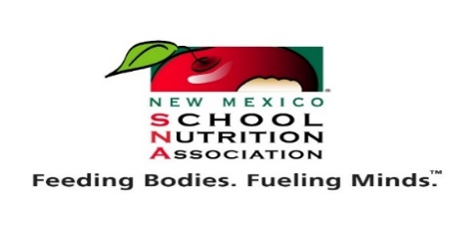
NMSNA State Conference Schedule of Events

Tuesday, June 2, 2026 Pre-Conference- On-hands cooking classes 10:00-4:00 pm
*Must have own transportation to the Indian Cultural Center (Optional-Free)
Wednesday, June 3, 2026
7:00 am Registration & Lite Breakfast

10:00 am Breakout Session/Class
11:00 am – 12:30 Lunch (provided)
12:30 – 5:00 Breakout Sessions/Classes
Thursday, June 4, 2026
7:00 am Registration & Lite Breakfast
8:30-9:30 Breakout Sessions/Classes
9:30-1:30 Exhibits for Directors & Buyers
9:45-11:00 Breakout Sessions/Classes
11:00-1:30 Exhibits for ALL
1:30-5:00 Breakout Sessions/Classes
6:00-10:00 Banquet & Evening Entertainment
Friday, June 5, 2026
8:00 am-11:00 am Last General Session, Awards, Swearing in of new Officers & Keynote

